🔋
Integrated ESP32 Battery Management System
Production-Grade Battery Intelligence, Safety, Fault Tolerance & IoT Monitoring
Project Report
Platform: ESP32 DevKit V1 • Simulation: Wokwi • Cloud: Blynk IoT
Architecture: Unified Integrated System — Six Interconnected Modules

1. Introduction
The Integrated ESP32 Battery Management System (BMS) is a unified embedded-systems project that monitors a simulated four-cell lithium-ion battery pack and delivers battery intelligence, safety protection, a local diagnostic interface, fault-tolerant runtime behaviour, cloud telemetry, and an executive dashboard — all within a single Wokwi simulation.
Rather than treating each capability as an isolated exercise, the project integrates six challenge tasks into one continuous data pipeline: sensing feeds analytics, analytics feeds safety logic, safety logic drives protection hardware and the fault-tolerant runtime, and the runtime's state is surfaced simultaneously through a local LCD, an IoT cloud dashboard, and an executive summary view.

1.1 Six Integrated Challenge Tasks
Task | Module | Main Function
Task 1 | Adaptive Multi-Cell Battery Intelligence Engine | Cell monitoring, SOC, imbalance, health
Task 2 | Event-Driven Safety Protection Kernel | Fault detection and protection
Task 3 | Intelligent Embedded HMI | LCD diagnostics and fault display
Task 4 | Fault-Tolerant Embedded Runtime System | Fault handling and recovery
Task 5 | Intelligent Cloud Telemetry Architecture | Blynk IoT and event telemetry
Task 6 | Executive Battery Intelligence Dashboard | Live analytics and operator information

2. Complete System Architecture
Data flows in one direction from the physical sensing layer through analytics, protection, and finally presentation, as shown below.
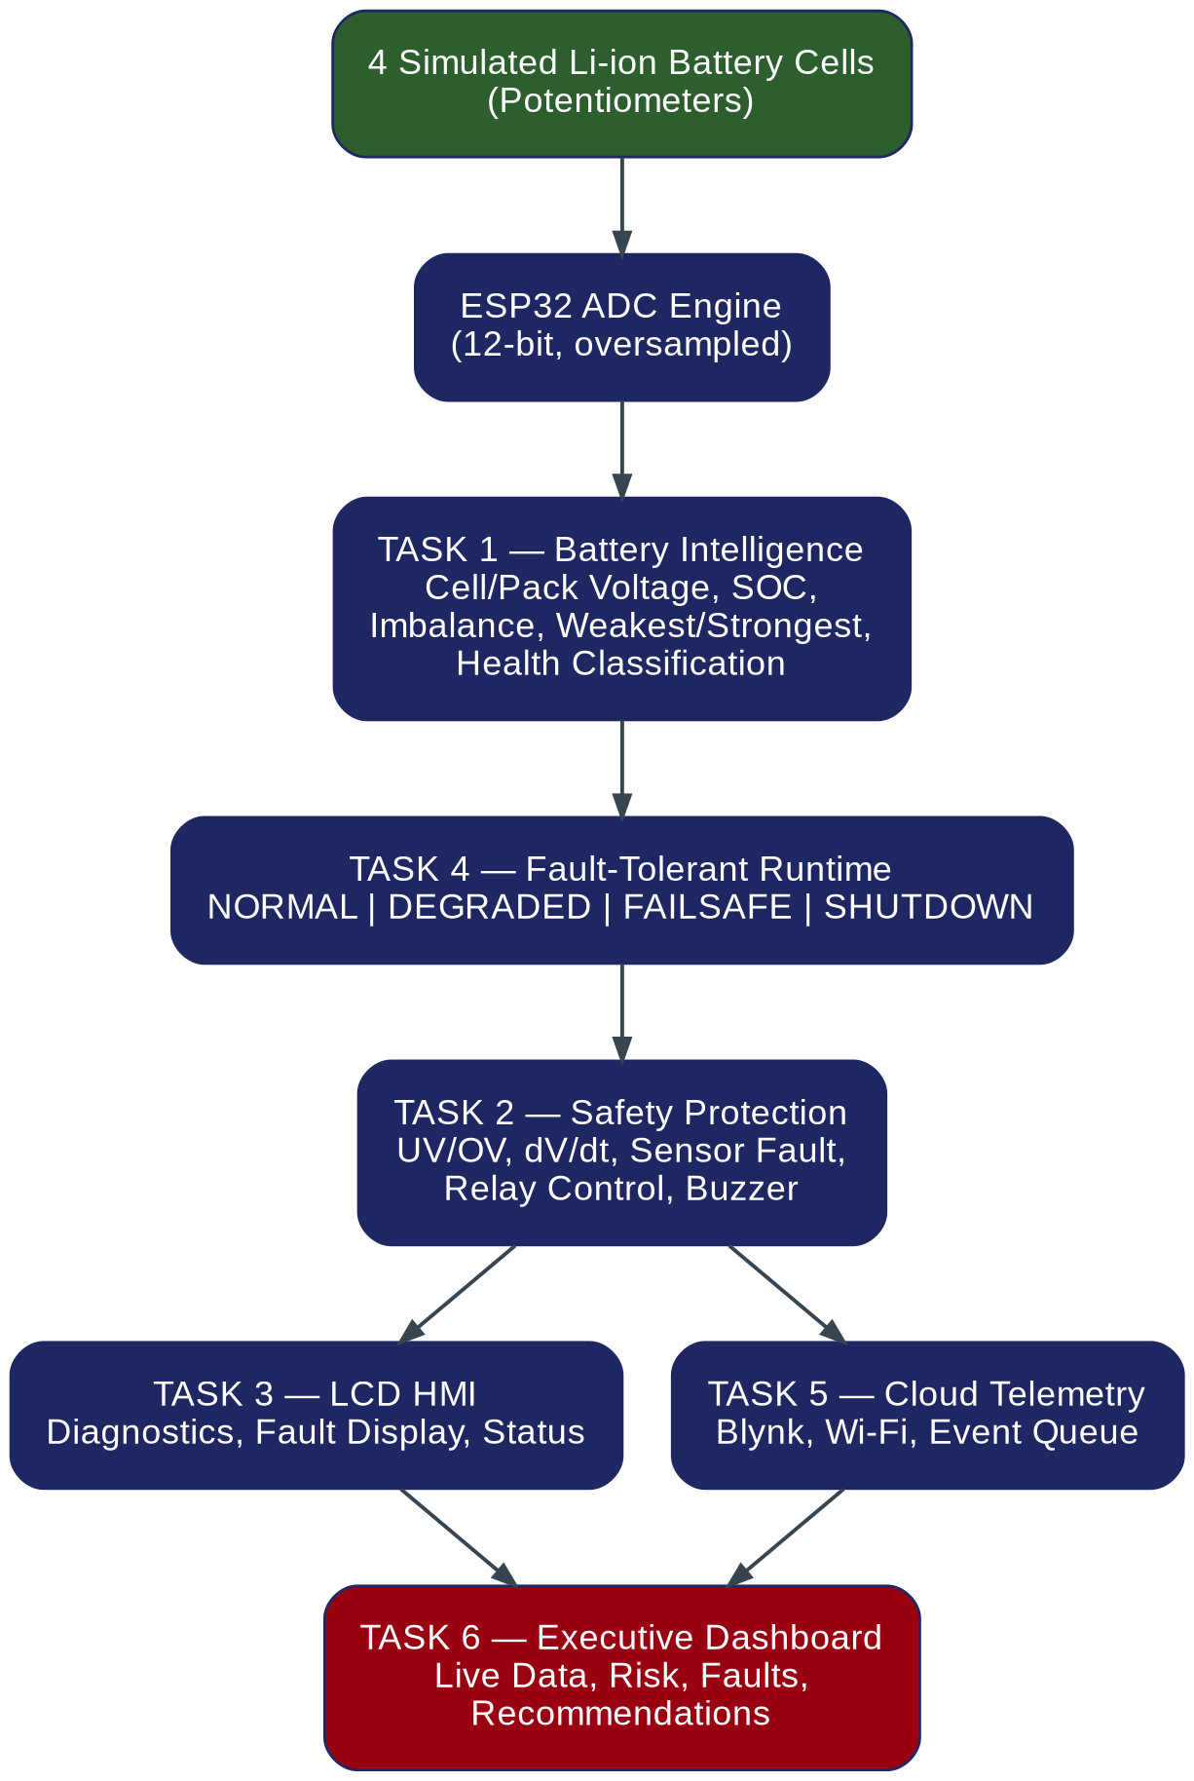
Figure 1: End-to-end module architecture — from cell sensing to the executive dashboard.

3. Hardware Components
The Wokwi prototype uses the following components, with the four potentiometers standing in for the four simulated lithium-ion cells:
- ESP32 DevKit V1
- 4 × 10 kΩ potentiometers (simulated cells)
- 16×2 I2C LCD with PCF8574 backpack
- 1 × relay module (battery protection cutoff)
- 1 × active buzzer
- Red, yellow, and green status LEDs
- Push button for HMI screen control
- Push button for fault injection / demo
- Relay feedback signal
- Blynk IoT cloud connectivity

3.1 Pin Configuration
GPIO | Component | Function | Direction
GPIO 34 | POT 1 | Cell 1 ADC | INPUT
GPIO 35 | POT 2 | Cell 2 ADC | INPUT
GPIO 32 | POT 3 | Cell 3 ADC | INPUT
GPIO 33 | POT 4 | Cell 4 ADC | INPUT
GPIO 21 | LCD | I2C SDA | I/O
GPIO 22 | LCD | I2C SCL | I/O
GPIO 13 | Relay | Relay command | OUTPUT
GPIO 14 | Buzzer | Fault buzzer | OUTPUT
GPIO 25 | Red LED | Critical / Fault | OUTPUT
GPIO 26 | Yellow LED | Warning / Imbalance | OUTPUT
GPIO 27 | Green LED | Healthy | OUTPUT
GPIO 18 | Push Button | HMI screen control | INPUT
GPIO 19 | Relay feedback | Relay status verification | INPUT
GPIO 23 | Push Button | Fault injection / demo | INPUT
GPIO 34 and 35 are input-only pins, making them well suited to analog sensor inputs; GPIO 32 and 33 are also configured as ADC inputs. The I2C LCD is addressed at 0x27.

4. Wokwi Circuit Simulation
The complete circuit — four cell potentiometers, the ESP32, the I2C LCD, status LEDs, buzzer, dual relay modules, and both push buttons — was wired and simulated in Wokwi. The screenshot below shows the simulation mid-run, with a fault condition (frozen ADC signal) reported on the serial console.
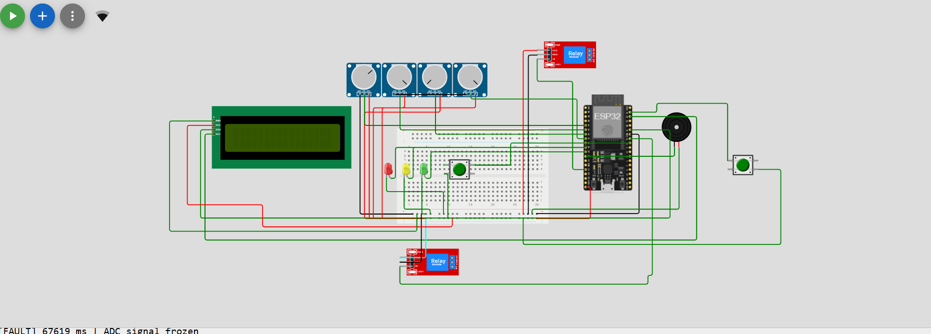
Figure 2: Wokwi simulation of the complete BMS circuit, showing a sensor-fault condition on the serial monitor.

5. Software Architecture
The firmware avoids blocking delay() calls and is organised into independent, millis()-scheduled modules:

5.1 setup()
- GPIO initialization
- ADC configuration
- LCD initialization
- Wi-Fi initialization
- Blynk initialization
- Safety initialization
- Runtime initialization

5.2 loop()
- readCells()
- calculateBatteryAnalytics()
- updateHealthState()
- runSafetyProtection()
- runFaultRuntime()
- updateHMI()
- processTelemetry()
- processEventQueue()
- updateDashboard()
- processButtons()

5.3 Timing Architecture
Module | Interval
ADC sampling | 100 ms
Safety evaluation | 100 ms
Runtime monitoring | 100 ms
HMI update | 100 ms
LCD screen rotation | 4 s
Wi-Fi retry | 10 s
Cloud events | Event driven
Queue synchronization | On reconnect

6. Task 1 — Battery Intelligence Engine
Each cell is oversampled eight times to reduce ADC noise, then converted from a 12-bit raw reading (0–4095) into a modelled cell voltage between 2.5 V and 4.2 V:
cellVoltage = 2.5 + (adcVoltage / 3.3) × (4.2 − 2.5), constrained to [2.5, 4.2] V
This is explicitly a simulation model — a real BMS would use a dedicated cell-sensing front end rather than connecting a lithium cell directly to an ESP32 ADC pin.

6.1 Pack Analytics
- Pack voltage = cell1 + cell2 + cell3 + cell4
- Average voltage = pack voltage ÷ 4
- Delta voltage = maximum cell − minimum cell

6.2 Cell Imbalance
- Individual imbalance = |Vcell − Vavg| ÷ Vavg × 100%
- Pack imbalance = (Vmax − Vmin) ÷ Vavg × 100%

6.3 State of Charge (SOC)
SOC uses a linear voltage-based model: SOC = (V − 2.5) / (4.2 − 2.5) × 100%, constrained to 0–100%, where 2.50 V maps to 0% and 4.20 V maps to 100%. This is a demonstration model, not a substitute for a chemistry-specific SOC estimator.

6.4 Health Classification
Battery health is derived from fault status and pack imbalance, as shown in the decision flow below.
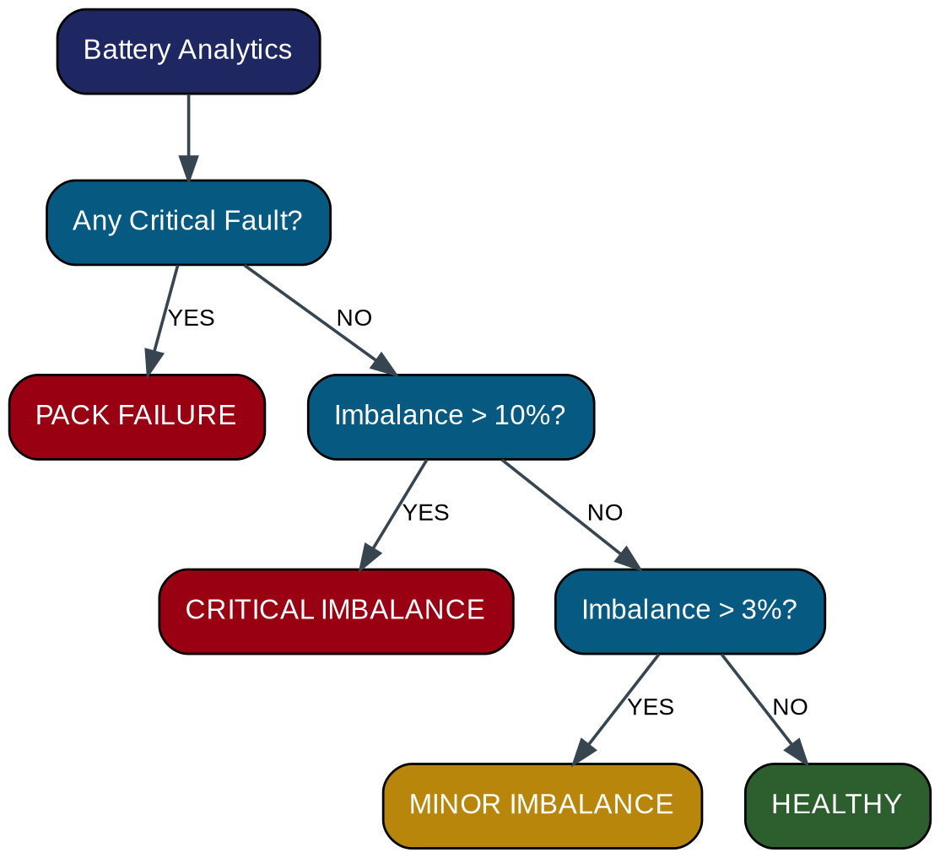
Figure 3: Health-classification decision flow.

7. Task 2 — Safety Protection Kernel

7.1 Safety Thresholds
Parameter | Value
Minimum modeled voltage | 2.50 V
Undervoltage fault | 2.80 V
Nominal reference | 3.70 V
Overvoltage fault | 4.15 V
Maximum modeled voltage | 4.20 V
Minor imbalance | > 3%
Critical imbalance | > 10%
Rapid dV/dt threshold | > 0.15 V/s
ADC resolution | 12-bit (0–4095)
ADC oversampling | 8 samples

7.2 Faults Detected
- Undervoltage
- Overvoltage
- Rapid voltage change (dV/dt)
- Sensor anomaly
- Relay mismatch (commanded vs. feedback)
- Invalid ADC reading

7.3 Non-Blocking Fault Debounce
A fault is confirmed only after it persists for a configured debounce period, rather than on a single noisy sample — this is implemented with millis()-based timers so the main loop never blocks.

7.4 Safety State Machine
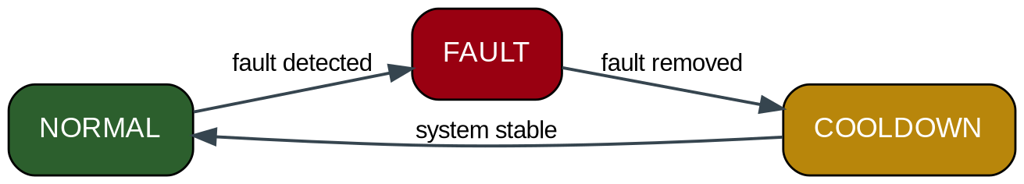
Figure 4: Safety-kernel state machine (NORMAL → FAULT → COOLDOWN → NORMAL).

8. Task 3 — Intelligent Embedded HMI
The 16×2 LCD automatically rotates through four diagnostic screens every 4 seconds:
- Screen 1 — Pack voltage, SOC, and overall health
- Screen 2 — Cell 1 & 2 voltages, weakest/strongest cell
- Screen 3 — Cell 3 & 4 voltages, delta voltage
- Screen 4 — Pack imbalance and relay status
During a critical fault, normal screen rotation is immediately overridden by a dedicated FAULT/WARNING screen. Rotation resumes automatically once the fault is resolved.

9. Task 4 — Fault-Tolerant Embedded Runtime
The runtime subsystem tracks four operational modes, escalating and recovering based on fault severity and persistence:
- NORMAL — all monitored subsystems operating normally
- DEGRADED — a non-critical fault exists while essential monitoring continues
- FAILSAFE — a serious fault is detected: relay OFF, buzzer ON, red LED ON, fault logged, cloud event generated
- SHUTDOWN — persistent or severe faults force a safe terminal state until explicit recovery
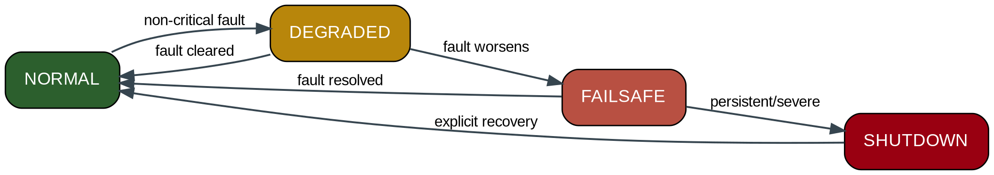
Figure 5: Fault-tolerant runtime state machine.
Each fault is logged as a structured event containing a timestamp, type, severity, affected cell, and measured value — for example: 5230 ms | UNDERVOLTAGE | CRITICAL | CELL 2 | 2.74 V.

10. Task 5 — Intelligent Cloud Telemetry
Telemetry is event-driven rather than continuous: data is transmitted to Blynk only when something meaningful changes — a health-state change, a significant SOC or imbalance shift, a fault, a threshold crossing, or a Wi-Fi reconnection. This significantly reduces network traffic compared with streaming every sensor sample.

10.1 Offline Event Queue
If Wi-Fi is unavailable, battery events are stored in a 20-event ring buffer. On reconnection, the queue is synchronized to the Blynk cloud in order, so no safety-relevant event is lost during a network outage.

10.2 Wi-Fi Signal Monitoring
Signal strength is read via WiFi.RSSI() and classified as Excellent, Good, Fair, or Weak for display on the dashboard.

11. Task 6 — Executive Battery Intelligence Dashboard
The dashboard is built on Blynk virtual pins, mapping each analytics output to a live widget:
Pin | Data | Widget
V0–V3 | Cell 1–4 voltage | Gauge
V4 | Pack voltage | Gauge
V5 | SOC | Gauge
V6 | Imbalance | Gauge
V7 | Health | Value
V8 | RSSI | Value
V9 | Event log | Terminal
V10 | Risk level | Value
V11 | Operator recommendation | Value
V12 | Weakest cell | Value
V13 | Strongest cell | Value
V14–V16 | Green / Yellow / Red indicator | LED

11.1 Operator Recommendations
The dashboard generates plain-language operator messages driven by battery state, such as: SYSTEM NOMINAL, MONITOR IMBALANCE, BALANCE CELLS, CHARGE SOON, STOP – LOW CELL, and STOP – OVERVOLTAGE.

11.2 Severity Indication
Overall severity escalates from GREEN (healthy) to YELLOW (warning / imbalance) to RED (critical fault), mirrored across the LCD LEDs, the physical LEDs, and the Blynk dashboard indicators.

12. Testing & Demonstration Procedure
Seven scenarios were used to validate the system end-to-end in Wokwi:
Test | Scenario | Expected Result
1 | Healthy battery — all cells ≈ 3.70 V | Health: HEALTHY · Green LED · Relay ON · Buzzer OFF
2 | Minor imbalance — one cell at 3.50 V | Health: MINOR IMBALANCE · Yellow LED · Recommend monitor/balance
3 | Critical imbalance — large cell gap | Health: CRITICAL IMBALANCE · Red LED · High risk · Balance cells
4 | Undervoltage — cell below 2.80 V | Fault · Relay OFF · Red LED + Buzzer ON · LCD warning · Cloud event
5 | Overvoltage — cell above 4.15 V | Overvoltage · Relay OFF · Red LED + Buzzer ON · Cloud event
6 | Sensor fault injection (frozen ADC) | DEGRADED → FAILSAFE, depending on severity/persistence
7 | Wi-Fi failure and reconnection | Local BMS continues; events queued; synchronized on reconnect

13. End-to-End System Flow
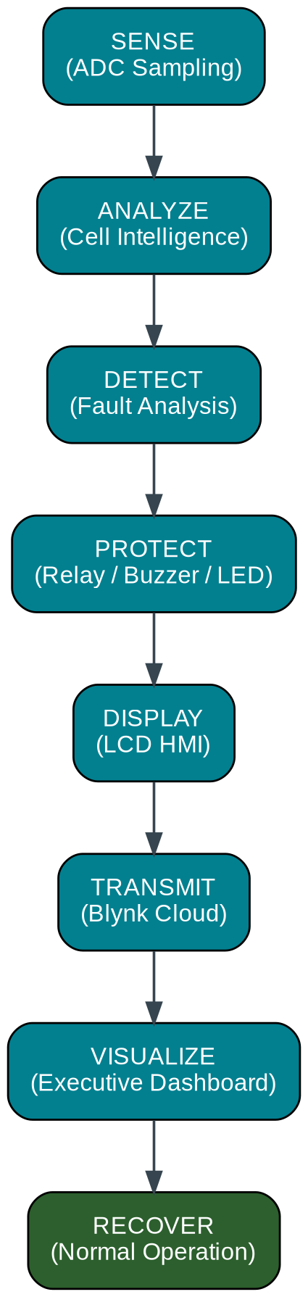
Figure 6: Complete sense → analyze → detect → protect → display → transmit → visualize → recover cycle.

14. Safety Note & Limitations
This project is an educational Wokwi prototype. The simulated voltage conversion, SOC estimation, thresholds, relay protection, and fault models exist to demonstrate embedded-systems architecture. They should not be used directly in a real EV, aircraft, industrial battery, or other safety-critical BMS without dedicated battery-monitoring ICs, galvanic isolation, redundant sensing, thermal monitoring, active balancing circuitry, validated protection logic, EMC testing, and applicable safety certification.

15. Technology Stack
Layer | Choice
Microcontroller | ESP32 DevKit V1
Language | C++ (Arduino framework)
Simulation | Wokwi
Cloud | Blynk IoT
Display | 16×2 I2C LCD
Communication | Wi-Fi
ADC | ESP32 12-bit ADC
Timing | millis() scheduler
Architecture | Event-driven / modular

16. Conclusion
All six challenge tasks — battery intelligence, safety protection, embedded HMI, fault-tolerant runtime, cloud telemetry, and the executive dashboard — were implemented as interconnected modules within a single Wokwi project and demonstrated together as one complete Battery Management System. The result is a cohesive, end-to-end BMS pipeline: sensing feeds analytics, analytics drives protection and the runtime state machine, and that state is simultaneously reflected on a local display, an IoT cloud dashboard, and an executive summary — with graceful degradation under sensor and network faults.

Skills Demonstrated
- ESP32 & embedded C++ · ADC interfacing · battery monitoring & analytics · SOC estimation · cell-balancing analysis
- State machines · event-driven programming · non-blocking firmware · millis() scheduling
- Fault detection, recovery, and logging · relay protection · buzzer control · LED diagnostics
- LCD HMI · I2C communication · Wi-Fi communication · IoT telemetry · Blynk · cloud dashboards
- Wokwi simulation · modular embedded architecture

